***CST 238: Graphical User Interfaces***

**Lab 9: Appendix A Installing Qt IFW**

* **READ EACH STEP CAREFULLY -**

**Note:** This guide only covers Qt5 installations using **Mingw** on **Windows**.  
**Note 2:** You may also find the ***Tutorial*** on Installer Framework more useful than this lab write-up. <https://doc.qt.io/qtinstallerframework/ifw-tutorial.html>

**Download and install Qt IFW:** [**https://wiki.qt.io/Qt-Installer-Framework**](https://wiki.qt.io/Qt-Installer-Framework)

1. Download the latest Qt IFW prebuilt (or build yourself).
   1. <http://download.qt.io/snapshots/ifw/installer-framework/19/>
   2. Extract the ifw-bld folder and all its contents into Qt install directory. (**C:/Qt** - *often*)
   3. Open the ifw-bld directory and then navigate and open ‘docs/html’.
   4. Take notice of the extensive help and documentation files contained.

**The rest of the lab (except deployment) is not specific to one system .**

***CST 238: Graphical User Interfaces***

**Lab 9: Appendix B Creating Your Config.xml**

* **READ EACH STEP CAREFULLY -**

**Create Folder Structure and config.xml:**

1. Inside your source directory create the following folder structure:
   1. **NOTE** for com.vendor.app use **com.(Organization).(ApplicationName)**
      1. Example: **com.oit.blasteroids** or **com.cst238.mediaplayer**

**Installer** //Create this directory in the same directory as your project file

**|----- config**

**|----- packages**

**|----- com.vendor.app**

**|----- meta**

**|----- data**

2.Create a file in the **config** directory called ‘*config.xml’*. **Add contents**: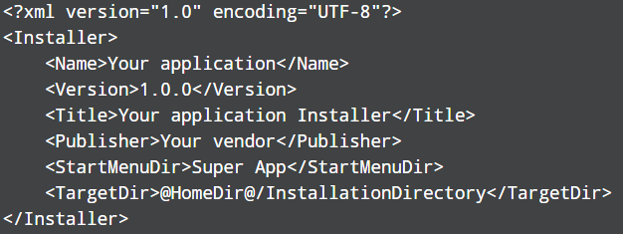

Fill in with your application information.

**Read more** here : <https://doc.qt.io/qtinstallerframework/ifw-globalconfig.html>

***CST 238: Graphical User Interfaces***

**Lab 9: Appendix C Creating Your Package**

* **READ EACH STEP CAREFULLY -**

**Create package.xml:**

Packages are “installable” components. Each package is described using a package.xml file. The actual files to be installed will be put into the ***data*** directory. The *package.xml* that describes the package should be put into ***meta*** directory.

**Note:** Multiple packages are great but your installer can use one package to install the entire game.

**1.)** Under your your package/*meta* directory make the ***package.xml*** file. **Add Contents:**

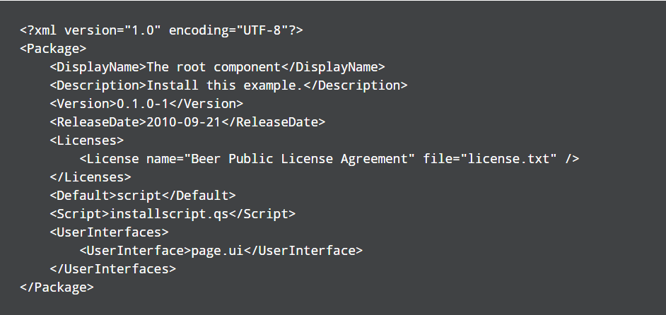

But fill in your application information. Key items - **<User Interfaces>** describes the pages you will have for this package. Similar **<Script>** is specific to the package. An example, a package to handle *shortcuts* (desktop and startmenu) would describe the “how” to check and generate those shortcuts in the **installscript.qs**.

**Package.xml file reference** - <https://doc.qt.io/qtinstallerframework/ifw-component-description.html#package-information-file-syntax>

***Read*** <https://doc.qt.io/qtinstallerframework/ifw-component-description.html#data-directory> then continue to step 2.

**2.)** Place the *contents* for the package in the **data** directory. What is content? A compressed archive likely containing EVERY file necessary for running the application. Libraries, binaries, assets (images, music, etc). - THIS IS DONE LATER IN THE LAB (continue on if you only have one package)

**3.)** If you have install scripts they should be placed in package/**meta**. (You are not required to have install scripts or an extra “page” (.ui). - if you don’t have these skip this section and “Creating Installer Pages” - move to “Generating Installer”). However, if you don’t have scripts or User Interfaces make sure to not include those in package.xml. And under **Default** put ‘true’.

Ultimately this is the end of creating the installer - understand the installer can get very complex depending on what you add. If you would like to improve continue reading: **Creating a Package Information File** section on the tutorial link on page 1.

**4.)** Repeat steps 1-3 over and over until all components/packages are added.

***CST 238: Graphical User Interfaces***

**Lab 9: Appendix D Creating Installer Pages**

* **READ EACH STEP CAREFULLY -**

**Creating Pages:**

If you have not discovered yet, Qt has a Designer tool. Using the designer tool you can generate pages for your installer.

<http://doc.qt.io/qtinstallerframework/ifw-customizing-installers.html>

**1.)** Open the Qt Designer tool:

C:/Qt/<Qt Version>/<Qt installation>/bin/designer.exe

**2.)** Choose **widget** from the dialog type on the left and then click **create**.

**3.)** Use the designer tool to build your UI file.

a.) <http://doc.qt.io/qt-5/qtdesigner-manual.html>

b.) <http://doc.qt.io/qt-5/gettingstartedqt.html>

**4.)** Save the .ui file with an appropriate name into your package/**meta** directory.

**5.)** Modify your **package.xml** file and add a **Userinterfaces** section. Then add a section to include the newly created .ui file.

<UserInterfaces>

<UserInterface> yourwidget.ui</UserInterface>

</UserInterfaces>

If you are lost on <tags> re-read the section on package information file syntax <https://doc.qt.io/qtinstallerframework/ifw-component-description.html#data-directory>

**6.)** If you have not added a qt script to your package, add it now

packages/meta/**package.qs**

**7.)Inside package.qs, Add the Component section into the script and the necessary lines to add your new .ui page**

function Component()

{ // this is your package constructor

component.loader.connect(this, Component.prototype.loaded); // make loaded connection

if(!installer.addWizardPage(component, "YourWidgetName", QInstaller.ReadyForInstallation))

console.log(“Could not load my widget”);

}

**Then later in the script you can do stuff when the user has entered your widget**

Component.prototype.yourWidgetNameEntered = function ()

{

var pageWidget = gui.pageWidgetByObjectName("YourWidgetName"); // handle to the widget

}

**8.) Read a lot more about scripting options, check out the examples.**

**a.)** Scripting - <http://doc.qt.io/qtinstallerframework/ifw-customizing-installers.html>

**b.)** Examples - <http://doc.qt.io/qtinstallerframework/qtifwexamples.html>

**c.)** Script Operations - <http://doc.qt.io/qtinstallerframework/operations.html>

**9.) Finish your installer.**

a.) Add more packages if you would like.

b.) Add shortcuts - startmenu or desktop if you want

c.) Add anything you want to to customize your installer.

***CST 238: Graphical User Interfaces***

**Lab 9: Appendix E Generating Installer**

* **READ EACH STEP CAREFULLY -**

**Locate Tools and Source Directories:**

1. Find the exact directory that **your project is located** in - this is absolute path
   1. example: **C:/Documents/MyProjectDir/src** - assuming *src* directory contains *<project_name>.pro*
   2. Copy the complete path to that directory into notepad (or any text file).
   3. Going forward this directory path will be referenced as **<SRC_DIR>**
2. Locate the exact directory that your **ifw tools** are located in (bin folder) - this is an *absolute* path
   1. example: **C:/Qt/ifw-bld/bin** -assuming this directory contains *binarycreator.exe*
   2. Copy this path to a directory into notepad (or any text file).
   3. Going forward this directory path will be referenced as **<TOOL_DIR>**

**\*\*\*\*\*Time to Start Windows Deployment:\*\*\*\*\***

<http://doc.qt.io/qt-5/windows-deployment.html>

**Creating a “release” of your project:**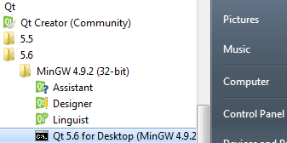

**1.)** Under **Qt** in your start-menu or (**cmd.exe** and run **qtenv2.bat** in C:/*Qt/<version>/mingw/bin*) open the **Qt command line environment**.

**2.)** Then navigate to your **source directory.** Use your path for <SRC_DIR>.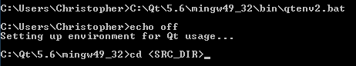

**3.)** To clean your directory run **mingw32-make clean.** If your makefile doesn’t exist this will fail (don’t worry that is fine).

**4.)** Now generate your project makefile in release mode using the *qmake* tool.

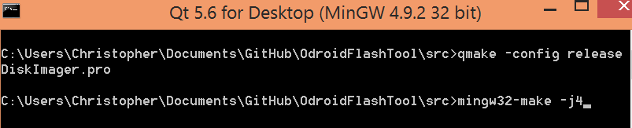

**qmake -config release yourproject.pro**

**mingw32-make -j(number of threads to use to build)**

**5. )** Now ‘cd’ into the **release** folder and clean the object files and meta compilers files out.  **del *.o *.cpp**

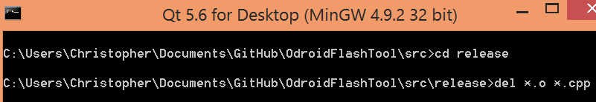

**6. )** Now it is time to run **windeployqt** tool - grab your notepad with directories saved and input the command as: **windeployqt --qmldir <SRC_DIR> <SRC_DIR>\release**

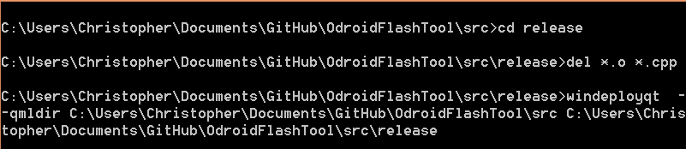

**7. )** Then use the archivegen tool or 7zip to zip the archive.

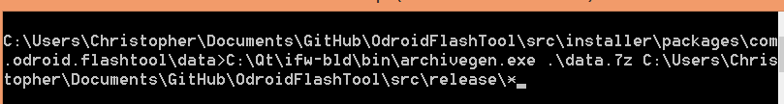

Command syntax:

**<TOOL_DIR>\archivegen.exe <NAME_OF_ARCHIVE.7z> <SRC_DIR>\release\\***

**8. )** Verify the contents of your component package (open the archive and analyze the folders). Then extract a copy of the folders to the Desktop and try to launch your application.

**9. )** Now it is time to generate the installer! - run this final command

**<TOOL_DIR>\binarycreator.exe --offline-only -t <TOOL_DIR>\installerbase.exe -p <SRC_DIR>\installer\packages -c <SRC_DIR>\installer\config\<config_file> <installer_name>**

**Alternatively:**

<TOOL_DIR>\binarycreator.exe --offline-only -t <TOOL_DIR>\installerbase.exe -p installer\packages -c installer\config\<config_file> <installer_name>

Must you must be in the <SRC_DIR> when running like this

**Example:**

C:\Qt\ifw-bld\bin\binarycreator.exe --offline-only -t C:\Qt\ifw-bld\bin\installerbase.exe -p C:\Users\Christopher\Documents\GitHub\OdroidFlashTool\src\installer\packages -c C:\Users\Christopher\Documents\GitHub\OdroidFlashTool\src\installer\config\config.xml "Odroid Flash Tool Installer”

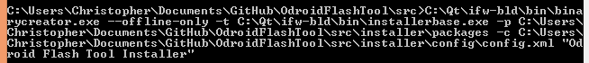

Remember this is all one line.

If you a have resource (for the installer) make sure to reference it with the **-r** switch

<http://doc.qt.io/qtinstallerframework/ifw-tools.html#summary-of-binarycreator-parameters>

**10 .)** The installer will be built in you $PWD so navigate to it and run the installer to test everything. If there are issues with the way your installer page is displayed. Then work on your pages mores and repeat **step 9**.

**Resources:**

[**https://github.com/chessgames/play-zone/tree/dev_cdean/src/CG_mobileChess/installer**](https://github.com/chessgames/play-zone/tree/dev_cdean/src/CG_mobileChess/installer)